CJFAS Article

Habitat Complexity and Phenotypic Variation: Stream and Reach-scale Thermal Heterogeneity Structures Diverse Spawning Portfolios in Interior Chinook Salmon
Thermal heterogeneity structures diverse Chinook Salmon spawning portfolios across a stream network

Russell F. Thurow^{1*} (ORCID iD: 0000-0002-1362-8599)
Bryan M. Maitland² (ORCID iD: 0000-0002-4491-5064)
Morgan M. Sparks² (ORCID iD: 0000-0003-0787-2218)
Daniel J. Isaak² (ORCID iD: 0000-0003-2963-1546)
John M. Buffington² (ORCID iD: 0000-0002-2513-5863)

¹US Forest Service, Rocky Mountain Research Station (Emeritus), Salmon, ID, USA 83467
²US Forest Service- Rocky Mountain Research Station, Boise, Idaho, USA 83702.

*Corresponding author (e-mail: russ.thurow@usda.gov)
Abstract
Pacific salmon exhibit diverse life histories and local adaptation shaped by spatiotemporal variation in biotic and abiotic conditions. This biocomplexity buffers populations against environmental variability and reduces risks of demographic failure. One key aspect of biocomplexity is spawning phenology, a reproductive attribute that generates population resilience in Pacific salmon. However, the environmental mechanisms structuring spawn timing remain poorly understood. We analyzed 3,016 wild Chinook salmon (Oncorhynchus tshawytscha) redds georeferenced from 2002-2005 across eight tributaries to Idaho’s Middle Fork Salmon River and evaluated how stream- and reach-scale thermal conditions and spatial habitat variation influenced spawn timing. Linear mixed-effects models with stream-reach random intercepts and slopes explained most of the variation in observed salmon spawning dates (marginal R² = 0.698; conditional R² = 0.985). Spawn timing advanced nonlinearly with antecedent 90-day mean water temperature and plateaued at warmer sites. Stream and year effects were also significant, with spawning occurring progressively later through time. Importantly, reach-specific random slopes revealed pronounced heterogeneity in thermal sensitivity, suggesting that unmeasured local hydrologic and geomorphic processes mediate phenological responses to temperature. Together, these results demonstrate that fine-scale habitat heterogeneity, particularly thermal heterogeneity, structures diverse salmon spawning portfolios. Notably, we documented the persistence of highly diverse spawning portfolios within this interior Chinook salmon population despite extremely low contemporary abundances and its “Threatened” status under the U.S. Endangered Species Act. Conserving diversity in spawn timing across heterogeneous habitats in dynamic environments may be critical for maintaining the adaptive capacity of Chinook salmon to a warming climate.
Keywords
Spawn timing, portfolio effect, biocomplexity, life history diversity, phenotypic plasticity, habitat heterogeneity, resilience
Introduction
Pacific Salmon populations exhibit extraordinary life history diversity, shaped by complex and heterogeneous environments across their range (Brannon et al. 2004). The enormous diversity of salmon life history traits (Waples et al. 2004) evolved in response to spatiotemporal variation in both biotic and abiotic conditions (Stearns 1976) and acts to reduce risks of demographic failure by buffering populations against environmental change and exploitation (Hilborn et al. 2003, Greene et al. 2009; Schindler et al. 2010; Beamish 2016). Chinook salmon (Oncorhynchus tshawyscha) display an especially diverse demographic portfolio characterized by a broad array of phenotypes, including variation in age and timing of seaward migration, duration of freshwater and marine residence, ocean distribution, age and season of spawning migration, and timing of spawning (Healey 1991).
Among these traits, spawning phenology has important ecological and evolutionary consequences. The timing of adult migration and spawning can shape reproductive isolation among temporally segregated groups and lead to fine-scale local adaptation (Manhard et al. 2017). While run timing (entry into freshwater) is often used to define populations segments (Brannon et al. 2004; Waples et al. 2004), here we focus on spawn timing (the date adults deposit fertilized eggs in gravel), as a fine-scale expression of phenotypic variation. Streams provide spatially heterogeneous natal habitats essential for salmon spawning and rearing life stages (Jacobs et al. 2023). Time of spawning is determined by season of entry into freshwater, length and speed of river migration, and time spent in a pre-spawning stage (Ricker 1959). Salmon spawn timing is a key trait in population divergence because it reflects adaptation, strongly influences other traits, and augments spatial isolation of populations (Quinn et al. 2001). Spawn timing varies within and across salmon populations and has a well-documented genetic component (Ricker 1972; Quinn et al. 2002; Beulke et al. 2023). For example, high site fidelity and limited straying spatially segregates related individuals on spawning grounds and leading to fine-scale genetic structuring (Neville et al. 2006). Spatial heterogeneity in habitat conditions likely promotes this diversity by selecting for locally adapted phenologies (Ruff et al. 2011).
Temperature strongly influences salmonid spawn timing (Hendenon 1963; Morrison and Smith 1986; Beechie et al. 2008). Because embryonic development rates are mechanistically driven by ambient temperature (Sparks et al. 2025), salmon tend to spawn at times that ultimately synchronize fry emergence with conditions that optimize offspring growth and development (Quinn 2018; though see Sparks et al. 2019). Several studies have linked site-specific thermal regimes to observed variation in spawning phenology (Sheridan 1962; Burger et al. 1985; Heggberget 1988; Lisi et al. 2013). However, although the importance of temperature as a determinant of spawn timing is well established, the underlying landscape features that may drive thermal variation (i.e., physiography, geomorphology, and hydrology), are poorly understood (Montgomery 1999; O’Sullivan et al. 2019). Geomorphic attributes including slope, elevation, confinement, and groundwater connectivity can shape reach-scale thermal regimes, thereby constraining or enabling different spawning strategies (Beechie et al. 2006, 2008; Jonsson and Jonsson 2011). Lisi et al. (2013), for example, demonstrated that variation in watershed slope, elevation, and lake area explained a large proportion of summer stream temperature and timing of Sockeye salmon (Oncorhynchus nerka) spawning in Alaskan streams, highlighting geomorphology’s indirect but powerful role in structuring phenological diversity.
The Middle Fork Salmon River (Middle Fork) supports one of the most intensively monitored wild Chinook salmon populations in the Columbia River Basin. Long-term redd surveys by state, federal, and tribal agencies provide a uniquely rich dataset for examining environmental drivers of spawning phenology. The Middle Fork supports wild, indigenous Chinook salmon populations unaltered by direct hatchery supplementation (Thurow et al. 2020) and the watershed is managed as a designated wild anadromous fish sanctuary (IDFG 2019). Minimal anthropogenic effects and a geographic size that facilitates natural processes (i.e., wildfire, floods, debris flows, and snow avalanches) ensure generation and maintenance of diverse environmental conditions (Isaak et al. 2003; Thurow 2015). These natural processes function relatively unimpeded by humans because most of the watershed lies within designated Wilderness. As a result, natal salmon habitats remain diverse, high quality, and connected, and exotic fishes are relatively uncommon (Thurow 2000; Isaak and Thurow 2006; Thurow 2015).
Phenology is far more difficult to measure than temperature so the relationship between fine-scale thermal heterogeneity and timing of salmon spawning is poorly understood (Deacy et al. 2019). Understanding the nature and causes of phenological diversity is of critical importance to recovery of Pacific salmon (Taylor 1991; Waples et al. 2004). We leveraged the Middle Fork’s unique characteristics and robust dataset to examine how variation in stream temperature and habitat attributes influence Chinook salmon spawn timing across multiple years in several tributaries. Characterizing variation in natural processes within stream networks and understanding how spatial and temporal variability in physical processes and Pacific salmon interact are critical, both for establishing recovery targets (Bisson et al. 2009), and for evaluating population persistence under changing environmental conditions (Isaak et al. 2018). Our objectives were to: 1) describe stream reach-scale physical attributes and Chinook salmon spawning phenology from 2002 to 2005, 2) summarize variation in spawn timing across four years in eight streams, and 3) fit a series of linear mixed-effects models to identify associations between environmental covariates and spawn timing.
Methods
Study Area
The Middle Fork drains ~7,330 km² of Central Idaho, predominantly within the Frank Church River of No Return Wilderness, and is one of eight original National Wild and Scenic Rivers designated in 1968 (Figure 1; NWSRS 2016). From its headwaters the Middle Fork flows 171 km before joining the Salmon River near Salmon, Idaho (USFS 1998; Minshall et al. 1981; Thurow et al. 2020). Approximately 800 km of mainstem and tributary habitat are accessible to Chinook salmon (Mallet 1974; Thurow 1985). Detailed study area information can be found in Minshall et al. (1981); Thurow (2000); Servheen et al. (2001); and Thurow et al. (2020).
Adult Chinook salmon migrate from the Pacific Ocean up the Columbia and Snake rivers to spawn in the Middle Fork, typically arriving in early summer and spawning from late July to mid-September. Salmon in this system express a stream-type life history, with most juveniles rearing for one year in freshwater before outmigration (Healey 1991). However, fish exhibit multiple freshwater (age 0-2) and saltwater (1-5) ages, in addition to non-migrating precocial males (Gebhards 1960; James et al. 1998; Copeland and Venditti 2009). Observations suggest that early-arriving adults tend to spawn at higher elevations and later arrivals spawn progressively lower in the basin (Fulton 1968; Gebhards 1959; IDFG 1992; Parkhurst 1950).
Despite the Middle Fork’s high quality natal habitat, its Chinook salmon are at high risk of extirpation (NOAA 2017). These fish belong to the Snake River spring/summer Chinook salmon Evolutionarily Significant Unit (ESU), listed as “Threatened” under the Endangered Species Act (ESA; NMFS 1992). Current salmon populations average 1-3% of the abundances that annually returned into the mid-1960s (Thurow et al. 2020). Altered migration corridors are considered a proximate cause of salmon declines in the upper Snake River basin in recent decades (Jacobs et al. 2022). NOAA (2022) stated that the centerpiece recovery action is restoring more normalized reach-scale hydrology and hydraulics, and thus river
conditions and function in the lower Snake River and emphasized the urgency of actions is accentuated by climate change.

Reach selection, Chinook salmon redd counts, and spawn timing
From 2001-2005, we selected study reaches in six major drainages (Big, Bear Valley, Camas, Loon, Marsh, and Sulphur creeks) and included Beaver Creek (tributary to Marsh Creek) and Elk Creek (tributary to Bear Valley Creek) to total eight salmon spawning tributaries that encompass a range of variation in elevation, stream size, and spawn timing. To support collaboration and improve efficiency, some study reaches overlapped with existing index reaches monitored annually by the Idaho Department of Fish and Game (IDFG), the Nez Perce Tribe, Shoshone Bannock Tribe, or the U.S. Forest Service (see Thurow et al. 2020 for index reach methods and locations). Spawning occurs across a broad elevation range, from <920 m in the lower mainstem to >2000 m in tributary headwaters. After selecting reaches, surveyors designated and marked subsections where redds would be identified and georeferenced.
Redd surveyors intensively monitored Chinook salmon spawning from the onset of redd construction through the completion of spawning. From late July through mid-September, trained observers walked stream banks within each study reach on 3-4-day intervals and searched for newly constructed redds. Surveyors began searching for redds before the onset of spawning and georeferenced redd locations with GPS units. To avoid commission errors during the initial survey, surveyors recorded all prior year redds or redd-like streambed features that might have been confused with newly constructed redds. Based on our prior observations in the Salmon River basin, female Chinook salmon typically remain on excavated redds for 3-5 days. Consequently, we assumed our 3-5-day survey interval maximized the likelihood of detecting all redds soon after their construction.
Based on our survey intervals, we inferred spawn timing from the first date a redd was fully constructed. Redd locations were spatially joined to stream reaches in the NHDPlus dataset (Moore et al. 2019) and assigned a common identifier (COMID). This identifier was used to link each redd with environmental covariates measured in or derived from the corresponding stream reach (i.e., COMID). We excluded data from 2001, and from Knapp and Cape Horn creeks (Marsh Creek tributaries) because of inconsistent sampling. The final dataset contained 3,016 georeferenced redds (i.e., inferred spawn date) across 104 stream reaches (i.e., COMIDs), nested within the eight spawning tributaries listed above, and spanning four years.

Covariates
To identify environmental predictors of spawn timing, we linked each redd location to stream temperature, discharge, elevation, and slope at the stream reach scale (COMID). Covariates were selected based on ecological relevance, full coverage across the study area, and low collinearity (Appendix A1, Section 1.2). Elevation and slope were obtained from NHDPlus (Moore et al. 2019). We indexed thermal conditions using modeled daily stream temperatures at the COMID level from Siegel et al. (2023) after confirming strong agreement with temperature logger data measured in Idaho (Figure A1.7). Stream discharge data were drawn from a single USGS gage (13309220) near the basin outlet. For each redd, we calculated sequential time-windowed summaries of temperature and flow—i.e., 30-, 60-, and 90-day averages prior to, during, and following the inferred spawn date.
Initially, we established the appropriate modeling framework using exploratory data analysis and visualizations to evaluate variation in spawn timing across years and streams, examine bivariate relationships between spawn date and continuous covariates, and assess pairwise correlations among predictors (Appendix A2). Based on these results, we retained 90-day antecedent temperature as a focal thermal covariate; post-spawn and fixed-date summaries were more weakly associated with spawn timing and showed higher collinearity. Elevation exhibited a weak association with spawn timing and was retained for its ecological interpretability, while slope was uncorrelated but provisionally retained. Although 90-day antecedent streamflow was initially considered, we excluded it because of poor spatial resolution, strong collinearity with year, and limited ecological relevance at the reach scale.

Data analysis
We used linear mixed-effects models to evaluate environmental predictors of Chinook salmon spawn timing, with redd observation day-of-year as the response variable. Continuous covariates were scaled (mean = 0, SD = 1) to aid convergence and model interpretation. All models included a random intercept for `COMID` to account for repeated measures across stream reaches. Further, based on exploratory analysis and biological expectations of nonlinear thermal responses, we modeled temperature effects using both linear and quadratic terms for the 90-day average stream temperature prior to spawning (temp_90).
We fit 31 additive models representing all combinations of fixed effects (temp_90, stream, year, slope, and mean elevation; Appendix A3.1). Candidate models were fit using maximum likelihood to allow direct comparison across differing fixed-effect structures. We also tested whether model performance improved by allowing the effect of temperature to vary across stream reaches by adding a random slope for 90-day antecedent temperature term to the COMID grouping factor. This random slope model was fit with restricted maximum likelihood (REML) and compared to the simpler random intercept model. To determine whether the quadratic 90-day antecedent temperature term remained necessary with random slopes, we re-fit the model with and without the quadratic effect using maximum likelihood. Finally, we evaluated whether additional fixed-effect interactions improved model performance by adding interaction terms between 90-day antecedent temperature and either stream or year. Model selection was based on AIC, and model performance was evaluated using marginal and conditional R², RMSE, and intraclass correlation coefficients (ICC).

Results
Spawn timing variation in space and time
Across all streams and years, Chinook salmon spawning exhibited a broadly unimodal distribution, with most activity concentrated between mid-August and early September (Figure 2A). The global mean spawn date was day 240 (August 28th), although year-specific means varied by nearly three weeks (Figure 2A). Stream-level spawning distributions revealed additional spatial structure (Figure 2B), with some streams (e.g., Bear Valley and Beaver creeks) exhibiting narrower peaks, while others (e.g., Big and Camas creeks) displayed broader or later distributions. A year effects were also evident (Figure 2C), with 2005 skewed later than preceding years.
When examined jointly by stream and year, density curves illustrated that each stream expressed a characteristic spawn timing “signature”; although the strength and consistency of the signature varied (Figures A1.3-1.4). Some streams (e.g., Beaver and Marsh creeks) displayed sharp, highly synchronous peaks, whereas others (e.g., Big, Camas, and Elk creeks) exhibited broader, more heterogeneous distributions. These stream-level differences were nested within year effects, reinforcing the combined influence of space and time on diverse spawning phenology.
The cumulative proportion of redds (Figure 3) provided an intuitive view of the pace and duration of spawning. Streams such as Marsh and Sulphur creeks exhibited rapid increases, suggesting short, concentrated spawning intervals. In contrast, Big and Camas creeks displayed more gradual redd accumulations, indicative of extended spawning seasons. Interannual variability was also evident, with some streams shifting substantially across years. Together, these patterns highlight the pronounced spatial and temporal heterogeneity in Chinook salmon spawn timing across the Middle Fork watershed.

Model comparison
We used AIC-based model selection to identify parsimonious models explaining spatial and temporal variation in spawn timing. Model comparisons identified stream identity, interannual variation, and nonlinear temperature responses as the strongest predictors of Chinook salmon spawn timing, while topographic variables contributed less consistently (Table 1). Model m26 had the lowest AIC among the candidate models, yet predicted later spawning at higher elevations which is counter to raw data patterns (Figure A3.1) and observations confirming earlier spawning in cooler, high elevation reaches. Therefore, we did not retain m26 despite its statistical support. Model m31 (added slope to m26) performed nearly identically (ΔAIC = 2) and retained the same inaccurate elevation effect, leading us to exclude it as well. Model m27 (replaced mean_elevation with slope) performed substantially worse (ΔAIC > 110, lower marginal R²), indicating that elevation, not slope, was the topographic driver of likelihood gains. Together, these results suggest that topographic terms improved model likelihood but introduced biologically implausible effects, likely a result of collinearity with temperature and confounded with stream identity (Appendix A3.1). We therefore selected model m16 (temp_90 + quadratic term + stream + year) as the most interpretable and parsimonious model. Model m16 had nearly identical predictive accuracy (RMSE = 2.02) and conditional R² (0.980) compared to m26, despite a modest reduction in marginal R² (0.729 vs. 0.785). We used this model as the base structure for our subsequent evaluation of random slopes and interaction terms.
To account for site-level variation in thermal sensitivity, we extended the additive base model by adding COMID-specific random slopes for temperature. This substantially improved model fit (ΔAIC = 510), reduced prediction error (RMSE = 1.78 days), and slightly increased conditional R², indicating that temperature effects vary meaningfully among stream reaches and are better represented as random slopes (Table 1).
We next evaluated whether the quadratic temperature term remained necessary in the presence of random slopes. The model including both random slopes and a quadratic temperature effect outperformed the linear version (ΔAIC = 20.4), suggesting that both components contributed complementary information (Table 1).
Finally, we assessed whether interactions between temperature and either stream or year provided additional explanatory power. Although the model including temp_90 × year exhibited a large AIC improvement, it predicted an implausible, inverted quadratic response, suggesting overfitting or confounding. The model with temp_90 × stream produced more reasonable predictions yet offered minimal improvement, and most interaction terms were non-significant. These results confirm that the random slope structure already accounts for much of the variation captured by fixed-effect interactions (Table 1).
These results led us to retain the random slope model, without interactions, as our final model (m16_rs), which we refit with REML for interpretation. This model balances explanatory power, biological realism, and parsimony: it captures general patterns in spawn timing via fixed effects and accommodates local deviations in thermal sensitivity via random slopes. Consequently, this model structure formed the basis for subsequent diagnostics, predictions, and ecological interpretation.

Final model fit and diagnostics
Model fit for the final model (`m16_rs`) was strong: marginal R² (fixed effects only) was 0.698, while conditional R² (fixed + random effects) was 0.985 (Table 2), indicating that most explanatory power came from spatially varying temperature responses. Combined with high ICC (0.95), these diagnostics and confirm that the final model effectively captured both broad-scale structure and stream-level heterogeneity in spawn timing.
Model diagnostics indicated strong performance and no violations of key assumptions (Figure A4.1). Residual plots revealed acceptable linearity and homoscedasticity: although the residuals vs. fitted values showed a slight trend and some funneling at lower fitted values, these patterns were minor and likely reflect skew in early spawn dates rather than model misspecification. The normal Q-Q plot indicated slight right-skew and heavier-than-normal tails, but residuals were generally well-behaved. Random effect Q-Q plots for both intercepts and slopes were similarly close to normal. A small number of data points exceeded standard influence thresholds (|standardized residual| > 2, moderate leverage), but none were extreme enough to justify removal, and their influence was limited. Variance inflation factors (VIFs) for all fixed effects were below 2, suggesting low collinearity. The posterior predictive check showed excellent agreement between observed and predicted spawn timing, with overlapping distributions and no major deviations. Model predictions closely matched observed spawn timing, with predicted values aligning well along the 1:1 line (Figure A4.2).

Population-level effects
We estimated marginal mean spawn timing at each factor level and averaged it over the random effects, to provide an overall estimate of the effect in the population. We observed significant differences in spawn timing between many stream pairs (Figure 4A; Table A4.3), particularly in Loon Creek (later spawning) compared to Sulphur Creek (earlier spawning). For example, fish in Loon Creek spawned significantly compared to fish in Bear Valley, Camas, or Elk creeks, while Sulphur Creek exhibited significantly earlier spawn timing than all other streams except Elk Creek. These patterns reflect spatial heterogeneity in temperature and elevation across streams, that are not fully captured by fixed effects alone.
There was a clear trend toward later spawning over the four-year period (Figure 4B; Table A4.4). Spawning in 2005 occurred significantly later than in all previous years. Although differences between 2002 and 2003 were not statistically significant, later years (2004 and especially 2005) were associated with progressively later mean spawn timing. This temporal shift likely reflects interannual variability in temperature and flow conditions.
Stream-specific predictions revealed a consistent pattern: spawn timing increased nonlinearly with 90-day mean antecedent stream temperature and leveled off at high temperatures (Figure 5). This plateau is consistent with biological expectations, as spawning may be constrained by environmental or physiological thresholds. Stream-to-stream variation in predicted timing reflects both fixed stream effects and COMID-specific random intercepts and slopes. Year-specific predictions similarly exhibited consistent thermal responses across years, with modest variation in average spawn timing because of year effects.

Group-level effects (COMID deviations from population effects)
Random intercepts and slopes varied considerably among COMIDs ] (Figure 6A). We interpreted random intercepts as representing baseline differences among streams and years after accounting for fixed covariate effects. A positive intercept indicates a reach where salmon tended to spawn later than expected given temperature, stream, and year effects, whereas a negative intercept indicated earlier spawning than expected, both relative to that population-wide expectation. Random slopes illustrate how strongly each reach’s spawn timing responded to temperature relative to the overall population relationship, with steeper slopes indicating higher thermal sensitivity and shallower slopes reflecting weaker or buffered responses. Across COMIDs, intercepts and slopes were weakly negatively correlated (r = -0.2; Figure 6B), indicating that reaches with earlier spawning (negative intercepts) tended to have stronger temperature dependence. This pattern suggests that colder or higher-elevation reaches may exhibit broader variation in response to temperature change, whereas warmer or later-spawning reaches may already operate near thermal thresholds that limit further advancement.
Figure 7 further illustrates Middle Fork salmon population spawning variability across space. Panels A and B summarize the distribution of random slopes by stream, illustrating that some systems (e.g., Bear Valley Creek) exhibited high variability in intercepts (diverse local habitats), others (e.g., Marsh Creek) showed higher slope variability (heightened thermal sensitivity), while others (e.g., Camas Creek) exhibited both. Panel C links these deviations to predicted temperature–spawn-timing relationships for individual reaches, revealing how local intercept and slope variation manifest as a family of reach-specific trajectories around the population mean. While the overall relationship between pre-spawn temperature and spawn timing is positive and nonlinear, the strength and shape of this response varies among reaches, likely reflecting fine-scale differences in hydrology, geomorphology, or biological composition. Despite this heterogeneity, the consistency of the population-level trend underscores the biological relevance of water temperature as a dominant cue for spawning, with local processes and microclimatic buffering sustaining phenological diversity and resilience within Middle Fork salmon populations.

Discussion
We analyzed a highly spatially and temporally resolved dataset of more 3,000 Chinook salmon redds across eight streams and four years to investigate Chinook salmon phenotypic diversity and the environmental determinants of spawn timing. Antecedent 90-day mean water temperature had a large global effect as spawn timing increased nonlinearly and plateaued at warmer sites. Our linear mixed-effects models explained more of the variation in observed salmon spawning dates (marginal R² = 0.698; conditional R² = 0.985) compared to similar studies (e.g., Lisi et al. 2013). While the global effect of temperature was strong, the interpretation of our random intercepts and slopes, found high variability at the reach level, including within streams. Together, these results demonstrate that fine-scale habitat heterogeneity, particularly thermal heterogeneity, structures diverse Chinook salmon spatial and temporal spawning portfolios at both stream and reach scales.
Notably, these portfolios persist despite the Middle Fork’s extremely low contemporary salmon abundances and their “Threatened” status under the U.S. Endangered Species Act (NMFS 1992). Between 1995 and 2022, adult salmon returns averaged 1-3% of the abundances returning into the mid-1960s (Thurow et al. 2020). Although empirical data are not available to accurately estimate cumulative redds since 2022, we were able to compare redds counts in index reaches (Copeland et al. 2019; Thurow et al. 2020) within Bear Valley, Big, Camas, Loon, and Marsh creeks (data provided by M. Donovan (IDFG, Boise, ID 83707, USA), personal communication). The index counts reveal that adult salmon returns from 2023 to 2025 have not improved as contemporary abundances averaged 1-2% of mid-1960’s returns.
Multiple studies have proposed a causal relation between the thermal regime during incubation and the time of adult spawning (Heggberget 1988; Brannon et al. 2005). As Brannon stated, “The controlling mechanism in spawn timing, however, is the timing of fry emergence, which translates into fitness.” Our analysis of different pre- and post- spawn metrics, however, does not support the proposed incubation-spawn timing relationship. We suggest that habitat availability and survival during spawning may also be important selective forces in the pre-spawn and spawn life stages. We also found temperature at individual spawning sites to be highly correlated throughout the year, suggesting a latent effect. Our understanding of the mechanisms controlling salmon spawn timing would benefit from further evaluation of the incubation life stage. One promising approach might be to input Middle Fork temperature data into hatchR, a software ecosystem designed to predict hatch and emergence timing for wild fish populations (Sparks et al. 2019; 2025). hatchR enables users to input raw or summarized water temperature data, conduct basic data validation, and apply built-in parameterizations (Sparks et al. 2025).
The topographic variables we tested in our models (reach-scale: discharge, elevation, and slope) were weak predictors of spawn timing and introduced biologically implausible effects, likely a result of collinearity with temperature and perhaps confounded with stream identity. However, other researchers have reported that differences in topographic and geomorphic features among watersheds were associated with variation in water temperature and, subsequently, salmon spawn timing (Beechie et al. 2008; Lisi et al. 2013). Beechie et al. (2008) suggested that slope, elevation, and watershed area interact with climate to produce stream temperature regimes, discharge regimes, and sediment characteristics. Lisi et al. (2013) found clear associations between watershed features of streams and salmon spawn timing and postulated that those relationships were likely mediated by physical controls on stream temperatures through several mechanisms. The mechanisms included: topography influencing the heating capacity of streams through shading, hydrologic controls on residence time, water source, and groundwater exchange; watershed area controlling water volume; gradient; and secondary topographic features likely influenced by groundwater springs (Isaak and Hubert 2001; Lisi et a. 2013). Like Lisle et al. (2103), we also found thermal heterogeneity at the stream segment scale. Unlike Lisle et al. (2013), we did not observe a strong association between watershed-scale attributes and average thermal conditions. Our understanding of the mechanisms controlling salmon spawn timing would benefit from further investigation of the potential influences of landscape features on the temperature regimes salmon encounter in Middle Fork spawning reaches. Spatial Stream Network (SSN) models (Isaak et al. 2013) may be applicable for more rigorously examining relationships between topographic and geomorphic conditions and observed reach temperatures.
Additionally, although we excluded mean elevation as a fixed effect because of collinearity and inconsistent directionality, plots of random effects against elevation revealed underlying spatial structure that elevation helped explain. Within the Skagit River basin, catchment elevation and annual mean temperature were the physical factors that explained the most variation in salmonid spawning assemblage distributions (Austin et al. 2023). Consistent with prior observations in the upper Snake River basin (Fulton 1968; Gebhards 1959; IDFG 1992; Parkhurst 1950), early arriving adults tended to spawn earlier at higher elevations in the Middle Fork compared to later arrivals that spawned progressively later and lower in the basin. Similarly, Beechie et al. (2008) and Deacy et al. (2019) reported that Chinook salmon and Sockeye salmon, respectively, spawned earlier in cooler, high-elevation sites and later in warmer lower-elevation downstream sites.

Factors influencing phenotypic diversity
We observed significant differences in spawn timing within and between streams. Our modeling results underscore the biological relevance of water temperature as a dominant cue for spawning, with local processes and microclimatic buffering sustaining phenological diversity and resilience within Middle Fork salmon populations. In addition to thermal heterogeneity, variable thermal sensitivity of spawners and the abundance of spawning salmon may also generate phenotypic diversity.
Varying thermal sensitivity may be an important driver of phenotypic diversity. Phenotypic plasticity is the ability of the same genotype to produce a different phenotype when environmental conditions vary, and that process can lead to local adaptations that confer resilience (Waples et al. 2009). The nonlinear thermal responses and random slopes we observed highlight diverse thermal sensitivities of salmon spawning in different reaches. Our results also illustrate that fish spawning earlier in higher elevation reaches tended to have stronger temperature dependence. Biologically, this suggests that early-spawning populations are more phenotypically plastic, exhibited broader variation in response to temperature change, and adjusted their spawn timing more closely to thermal cues. In contrast, lower-elevation and later-spawning populations may be constrained by other factors such as photoperiod, migration fatigue, or compressed spawning windows, resulting in diminished thermal responsiveness. Lower elevation reaches may also be operating near thermal thresholds that limit further advancement. In addition to their higher plasticity, Crossin et al. (2004) reported that, consistent with evolutionary theory, difficult migrations appear to select for higher energy efficiency. Sockeye salmon traveling longer distances to higher elevation spawning sites expended less somatic energy per unit of migratory difficulty compared to salmon travelling shorter distances (Crossin et al. 2004). We are unsure if increased energy efficiency also influences the stronger temperature dependence we observed in early spawners.
Although very few studies that have examined the relationship between adult salmon returns and phenotypic diversity, there is evidence that broader spawning diversity might be expressed when more adults return. Davis (2015) examined the duration of salmon availability as a food source across three orders of magnitude in spawner abundances. Spawning salmon were available to predators up to 2.5 times longer at the largest vs smallest abundances (Davis 2015). This suggests that with larger escapements, salmon expressed more phenotypic diversity, specifically broader variability in spawn duration.
Historical records from the Middle Fork also suggest that spawning duration was broader when larger numbers of salmon returned. Big Creek, one of our study streams, supports spring/summer Chinook salmon that migrate into Big Creek from May to August and stage in pools or beneath cover near spawning sites. Fish in the “spring” segment enter sooner, migrate to higher elevations, and spawn from late July to September, compared to “summer” fish that enter later and historically spawned at lower elevations from mid-August to mid-November (Fulton 1968). In July 1879, Captain Bernard’s forces traveled down Big Creek and camped near Cave Creek. Dave Lewis wrote in his diary on July 28, 1879: “From there our scouts went down Big Creek to a point near Cabin Creek (a distance of ~ 2 km) and saw Indians setting fish traps on the riffles” (cited in Minshall 2014). Lewis’ quote suggests salmon were spawning near Cabin Creek in late July. Cabin Creek is in lower Big Creek and its salmon are considered part of the “summer” run segment that currently begins spawning in August, several weeks later than Lewis observed in 1879. Contemporary redd surveys are timed to coincide with the period of maximum spawning activity and the target date for Big Creek redd counts is September 5 (Copeland et al. 2019). In the 1870’s an estimated 8-10 million Chinook salmon annually entered the Columbia River and the commercial fishery that began in 1866 was still emerging (Lichatowich and Mobrand 1995). Harvest peaked in 1883 when canneries processed 43 million pounds of Chinook salmon, thereafter an annual harvest of ~25 million pounds was maintained until 1920 when natal habitat loss and overharvest caused population declines (Lichatowich 1999). Consequently, in 1879, salmon abundances in Big Creek far exceeded contemporary abundances which might be related to the historically earlier onset of spawning Lewis observed by the “summer” run segment.
Similarly, Chinook salmon in the adjacent South Fork Salmon River (South Fork) historically exhibited a broader spawning duration with larger abundances. In the diaries of L. G. Caswell, the November 9, 1899, entry states: “Shot a salmon 2-1/2 feet (76 cm) long”, this was near Elk Creek in the lower South Fork (Burns 1992). In 1983, Payette National Forest Fisheries Biologist Dr. David Burns and other Forest Service staff interviewed a longtime resident of the lower South Fork. This individual was a packer for the Forest Service in the 1930s and he described “dog salmon” that spawned in lower reaches of the South Fork in November (Burns 1992). There are no known recent records of salmon spawning after September in the South Fork, and September 5 is the target date for contemporary redd counts (Copeland et al. 2019). As in Big Creek, South Fork salmon abundances in the 1930s far exceeded contemporary numbers.
These provocative anecdotes combined with the escapement-spawn timing relationship Davis (2015) reported, suggest that when more adult salmon return, salmon expressed wider phenotypic diversity (broader spawn timing across more locations) compared to contemporary spawn timing with many fewer salmon.

Management and conservation implications
The Middle Fork represents a uniquely intact “reference system” for studying relatively undisturbed phenological processes that have potential to provide insights for guiding recovery efforts and informing temperature-based management thresholds. Frissell and Bayles (1996) recommended the identification of a reserve system constituting the best-remaining watersheds with relatively unimpaired biophysical processes and disturbance regimes and Waples et al. (2006) observed that if functioning natural ecosystems are conserved, natural evolutionary processes (leading to genetic and phenotypic diversity) will develop. The Middle Fork meets these criteria. Its Chinook salmon and steelhead (Oncorhynchus mykiss) populations are wild and indigenous, unaltered by hatchery supplementation. Consequently, the ability of the locally adapted salmon population to respond to topographic features and the quality and quantity of habitat has not been compromised. Such wild, indigenous, stream-type Chinook salmon populations rare; Thurow et al. (2000) reported their presence in 4% of the potential historical range and 15% of the current range in the Columbia River basin and portions of the Klamath River basin. Natural processes in the Middle Fork function relatively unimpeded by humans. Natal habitats remain diverse, high quality, and connected (Thurow 2000, 2015; Isaak and Thurow 2006). Within most of the drainage, habitat quality has not been substantially altered by anthropogenic activities, and exotic fishes are uncommon. Minimal anthropogenic effects and a geographic size that facilitates the existence of natural processes including wildfire, floods, debris flows, and snow avalanches ensure continual generation and maintenance of a diversity of stream habitats (Isaak et al. 2003; Thurow 2015). The large, connected basin area provides a diverse physical template for the expression of phenotypic diversity; the 7,330 km² basin includes 650 km of tributaries and 170 km of the mainstem accessible to Chinook salmon (Mallet 1974; Thurow 1985). In intact river basins like the Middle Fork, habitats are typically created or altered by physical processes interacting across multiple hierarchical spatial scales, ranging from microhabitats to habitat units, stream reaches, stream segments, and watersheds (Frissell et al. 1986; Fausch et al. 2002). Habitats with high connectivity permit the development of diverse life histories (Lichatowich and Mobrand 1995). The Middle Fork is also a very dynamic ecosystem. Schlosser (1991; 1995 a, b) reported that complex life histories result from disturbance and Lichatowich and Mobrand (1995) observed that life history diversity is “the solution to survival” in such dynamic environments. Consequently, the Middle Fork’s diverse habitat and dynamic environment provides a template for the expression of both genetic and life history diversity. Salmon populations like those in the Middle Fork can, as Williams (2006) observed, form the basis for rebuilding salmon abundance and diversity. Lisi et al. (2013) suggested that conservation strategies must maintain the networks of habitat used by salmon, not only to maintain evolutionary potential in salmon stocks, but also to provide options in foraging locations for wide ranging consumers (e.g., Schindler et al. 2010).
An important conservation/restoration question remains: do currently at-risk wild salmon populations retain the ability to express even broader phenotypic diversity, and will some currently absent life histories re-emerge if abundances are restored? Within the Middle Fork, annual, continuous redd counts were completed from 1995 to 2022 with the largest count in 2003 (Thurow et al. 2020). In 2003, adult salmon returns were the largest since the 1980s, and five of 33 redds in the mainstem were constructed nearly 10 days later than the latest redds observed in prior years (24–26 September versus 15–17 September) (Thurow et al. 2020). Those later redds were also constructed farther downstream from redds in most years. For example, on September 26, a pair of very large (3 or 4 salt fish) were observed spawning in much larger cobble substrate, compared to the gravels where mainstem redds were observed in prior years. These observations illustrate that as Middle Fork salmon abundances increased, salmon spawned later, and spawners were observed in formerly unused habitats. Buffington et al. (Paper submitted to the Canadian Journal of Fisheries and Aquatic Sciences, January 2025) predicted reach-average substrate size and salmon redd spatial distribution in the Middle Fork as a function of channel characteristics and confirmed that as escapements increased, salmon spatially expanded the range of substrate used and occupied more stream reaches. Similarly, after Elwha River dam removal, spawning Chinook salmon expanded into new habitats and their abundance, productivity, and spatial distribution increased (Pess et al. 2024). Pess et al. (2024) also reported the re-emergence of a unique steelhead life history type (summer run), although the “spring” Chinook salmon life history type had not yet emerged since dam removal in 2012. Elwha River steelhead also expressed anadromous life history diversity in populations formerly isolated above dams, suggesting those fish never lost their ability to express anadromy (Peters et al. 2025). Peters et al. (2025) reported preliminary analyses that suggest the diversity of steelhead life history strategies increased from 18 during dam removal to 28 in the years after dam removal. Population size is also known to influence dispersal and recolonization as larger populations result in relatively more individuals seeking new habitats (Pess et al. 2008).
These examples lend support to the possibility that the Middle Fork’s currently very small population retains the ability to express more phenotypic diversity as abundances increase. If true, it follows that when Middle Fork salmon populations are restored to higher abundances, the already very diverse spawning portfolio we documented will widen further. Conversely, if Middle Fork populations decline or remain at risk of extirpation because of currently low abundances and productivity (NOAA 2017), phenotypic diversity will likely contract, and spawning duration and distribution will narrow, likely resulting in a reduction in adaptation and resiliency. Loss of this interior stream-type Chinook salmon population would represent a loss of ecological and genetic diversity that Waples et al. (2004) deemed difficult to replace in evolutionary time frames.
To retain population persistence and resilience, it is vital to promote life history diversity by identifying, monitoring, and protecting unique phenotypic and genetic traits present within and among populations (Hugentobler et al. 2024). It is also vital to conserve the habitat heterogeneity (geomorphic conditions and hydrologic processes) that produces variation in salmon life histories (Lisi et al. 2013). Geomorphological and hydrological differences, and in our case diverse temperature regimes within and among streams, give rise to critical among-population life history diversity (Cordoleani et al. 2021). As Healey and Prince (1995) concluded, because of the dependence of phenotypic preservation on habitat, conservation efforts for Pacific salmon must focus as much on habitat and habitat opportunity as on genotype. Consequently, the critical conservation unit is the population within its habitat (Healey and Prince 1995). Hugentobler et al. (2024) similarly concluded that biocomplexity in run-types is essential to maintain salmon stock abundance and suggested that effective management promotes both genetic and phenotypic diversity, as well as the hydrological conditions needed to support that diversity. Furthermore, phenotypic diversity and the portfolio effect (Hilborn et al. 2003; Greene et al. 2009; Schindler et al. 2010), a mechanism that leads to increased population and community stability, is considered essential to maintain salmon stock abundance by buffering populations against environmental changes and extreme climatic events (Cordoleani et al. 2021; Hugentobler et al. 2024). To understand the resilience of individual and grouped populations to environmental perturbations, it is also important to consider abundance and other diversity and synchrony indicators (Cordoleani et al. 2021). Carlson and Satterthwaite (2011) stated that restoring salmon numbers becomes a management “priority” because more salmon increase population buffering. Actions that help diversify population structure, such as maintaining large populations sizes, may be critical (Greene et al. 2009).
Diverse spawning portfolios are also important for the large variety of species reliant on salmon as a keystone species (Wilson and Halupka 1995) and for the distribution of marine derived nutrients integral to community productivity and demographics (Wipfli and Baxter 2010). As Schindler et al. (2013) reported, variation in spawn timing enables mobile consumers to effectively locate profitable foraging opportunities over the course of the salmon spawning season. If spawning were perfectly synchronous across the watershed, consumers would have less time to capitalize on locally profitable foraging opportunities (Schindler et al. 2013). When spawning is asynchronous, because stream temperature variation may be expressed at relatively small spatial scales, consumers do not have to travel far to exploit the spatial and temporal variation (Schindler et al. 2013).
Finally, climate change is altering ocean productivity and salmon migration mortality (Crozier et al. 2019) and freshwater habitat (Luce et al. 2013; Isaak et al. 2018). Increasing water temperatures are predicted to reduce low elevation stream habitat, although some losses may be offset by warming of upstream reaches (Isaak et al. 2016). Despite its transformation of landscapes, the effects of climate change will differ among salmon populations because of extensive local adaptation and life history diversity (Crozier et al. 2008). Jacobs et al. (2021, 2022) assessed the potential effects of changes in summer stream temperature and discharge on the distribution of Middle Fork salmon spawning habitat under two future climate scenarios. Although many streams will remain cold water refuges, the effect of summer flow reductions is likely to reduce this buffer, leading to net losses of habitat in some high-elevation tributary streams (Jacobs et al. 2022). Despite these losses, substantial high-quality habitat will remain in many drainages and fire may mitigate some habitat losses by replenishing woody debris and spawning gravels (Jacobs et al. 2022).
Although the predicted persistence of high-quality Middle Fork spawning habitat is encouraging, to understand the effects of temperature change on salmon, it is important to understand the relationship between habitat, temperature, and phenology (Sparks et al. 2018). As Sturrock et al. (2018) observed, in environments facing increasingly volatile futures, it is prudent to promote and maintain diverse life-history portfolios. Diversity in the face of environmental uncertainty is the mechanism by which salmon populations spread the risk of mortality and dissipate the probability of extirpation (Den Boer 1968). Habitat heterogeneity and connectivity are deemed essential to support the diverse mosaic of habitats that fosters the expression of multiple salmon phenotypes, and salmon intraspecific diversity is critical for responding to changing climatic conditions and helping maintain the biocomplexity necessary for resilience and persistence (Cordoleani et al. 2021). Maintaining life history diversity is therefore vital to the resilience and stability of salmon metapopulations, particularly under changing climates (Hugentobler et al. 2024). The resilience of Bristol Bay Sockeye salmon provides an example of population-specific variability (the portfolio effect) in response to climate fluctuations (Hilborn et al. 2003; Schindler et al. 2010).

Limitations
The scale of our analysis, small sample sizes in a few streams, and a narrow range of adult salmon returns may have limited our ability to describe a more complete portfolio of Middle Fork salmon spawning phenologies. We collected data in six major drainages and two large tributaries (Beaver and Elk creeks) within those drainages (Figure 1). Four additional major drainages (Indian, Marble, and Pistol creeks, and Rapid River) and 160 km of the mainstem Middle Fork support spawning Chinook salmon (Thurow et al. 2020). Largely because of tributary remoteness and relatively few redds, we did not collect the data necessary to apply our analysis in those additional spawning areas. Within the drainages sampled, we also prioritized surveys in areas known to support a majority of redds. As a result, except for Marsh Creek, our redd surveys encompassed a relatively small proportion of the full diversity of habitats available to salmon (Figure 1). Although we completed a series of repetitive redd surveys (4-day intervals) in most of our study streams, some surveys in Beaver, Sulphur, and Marsh creeks were limited to one or two counts (Figure 3), thereby limiting our analysis in those streams and years. Finally, although adult salmon abundances fluctuated from 2002-2005, the range of those fluxes was relatively narrow compared to the abundances that formerly returned to the Middle Fork. From 2002-2005, annual adult salmon returns ranged from 1.9% to 9.4% of mid-1960s abundances (Thurow et al. 2020). As a result, the salmon population we sampled was far below salmon abundances necessary to fill the carrying capacity, resulting in many contemporary unused yet suitable spawning areas. Re-doing our analysis with larger adult spawning populations might reveal the expression of even broader phenotypic diversity than we detected. These limiting factors likely suppressed our ability to detect the full range of spawning portfolios expressed by salmon across the heterogenous Middle Fork landscape, resulting in a snapshot of very diverse, though likely incomplete, salmon spawning portfolios.

Acknowledgements:
We thank Don Anderson, Tyler Archibald, Steve Axon, Greg Burak, Matt Corsi, Ben Goodman, Lance Isaak, Casey Justice, Jared Lampton, Julie Markham, Steve Meyers, Chris Moeller, Russ Nelson, Wade Thorson, Quentin Tuckett, and Terry Williams for completing redd surveys and measuring environmental variables. Brian Leth of IDFG provided redd count data for reaches in Marsh Creek. John Guzevich of the Rocky Mountain Research Station assisted with crew training and supervision, and data collection. The Bonneville Power Administration provided funding for Project 2002-049-00 under Contract 00029186.

Competing interest statement:
The authors declare there are no competing interests. The findings and conclusions are those of the authors and should not be construed to represent any official United States Department of Agriculture or U.S. Government determination or policy.

Author contribution statement:
RFT conceived the study and acquired funding. RFT and DJI led the field work and created the georeferenced redd database. BMM and MMS completed data curation and formatting, conducted the statistical analyses, and visualized and interpreted model outputs. RFT drafted the original manuscript that BMM, MMS, DJI, and JMB reviewed and substantially edited.

Data availability statement:
Data and R scripts to run the analyses and generate the figures are available at https://github.com/morgan-sparks/mfsr_phenology and will be published archived upon acceptance on Zenodo.

References
*I will complete as you two review this Draft. Please insert any new references.

Tables and Figures
Tables 1, 2
Figures 1-7
Table 1. AIC table for linear models. For initial model comparison, the top 5 of 31 tested are shown.
Model | df | AIC | ΔAIC | Marginal R² | Conditional R² | RMSE | ICC
Initial model comparison
m26: yday ~ temp_90 + temp_90² + stream + year + mean_elevation + (1|COMID) | 16 | 13356.04 | 0 | 0.785 | 0.956 | 2.023 | 0.796
m31: yday ~ temp_90 + temp_90² + stream + year + mean_elevation + slope + (1|COMID) | 17 | 13358.04 | 1.998 | 0.785 | 0.956 | 2.023 | 0.795
m27: yday ~ temp_90 + temp_90² + stream + year + slope + (1|COMID) | 16 | 13468.96 | 112.925 | 0.737 | 0.979 | 2.022 | 0.922
m16: yday ~ temp_90 + temp_90² + stream + year + (1|COMID) | 15 | 13473.12 | 117.079 | 0.729 | 0.98 | 2.022 | 0.926
m29: yday ~ temp_90 + temp_90² + year + mean_elevation + slope + (1|COMID) | 10 | 13487.82 | 131.783 | 0.727 | 0.984 | 2.022 | 0.942
Random slopes for temp_90
m16_rs: yday ~ temp_90 + I(temp_90^2) + stream + year + (1 + temp_90 | COMID) | 17 | 12948.76 | 0 | 0.698 | 0.985 | 1.781 | 0.949
m16: yday ~ temp_90 + temp_90² + stream + year + (1|COMID) | 15 | 13459.05 | 510.283 | 0.714 | 0.981 | 2.022 | 0.932
Partitioning variation between nonlinearity and heterogeneity
m16_rs: yday ~ temp_90 + I(temp_90^2) + stream + year + (1 + temp_90 | COMID) | 17 | 12965.97 | 0 | 0.713 | 0.984 | 1.782 | 0.945
m16_rs_noquad: yday ~ temp_90 + stream + year + (1 + temp_90 | COMID) | 16 | 12986.41 | 20.441 | 0.714 | 0.984 | 1.788 | 0.943
Testing for interaction
m202: yday ~ temp_90 * year + I(temp_90^2) + stream + (1 + temp_90 | COMID) | 20 | 11568.63 | 0 | 0.62 | 0.994 | 1.359 | 0.985
m201: yday ~ temp_90 * stream + I(temp_90^2) + year + (1 + temp_90 | COMID) | 24 | 12948.51 | 1379.886 | 0.736 | 0.985 | 1.786 | 0.944
m16_rs: yday ~ temp_90 + I(temp_90^2) + stream + year + (1 + temp_90 | COMID) | 17 | 12965.97 | 1397.34 | 0.713 | 0.984 | 1.782 | 0.945

Table 2. Parameter estimates from the final model. CI represents the 95% confidence interval.
 | m16_rs
Predictors | Estimates | CI | p
(Intercept) | 235.09 | 230.95 – 239.22 | <0.001
temp_90 | 13.9 | 13.06 – 14.74 | <0.001
temp_90^2 | -0.85 | -1.15 – -0.55 | <0.001
stream [Beaver] | 17.41 | 10.62 – 24.19 | <0.001
stream [Big] | -0.19 | -5.37 – 5.00 | 0.944
stream [Camas] | 2.3 | -3.08 – 7.69 | 0.402
stream [Elk] | 11.97 | 4.88 – 19.06 | 0.001
stream [Loon] | 2.8 | -2.47 – 8.06 | 0.298
stream [Marsh] | 7.93 | 2.30 – 13.56 | 0.006
stream [Sulphur] | 14.69 | 8.69 – 20.69 | <0.001
year [2003] | -5 | -5.23 – -4.77 | <0.001
year [2004] | 2.77 | 2.53 – 3.01 | <0.001
year [2005] | 3.68 | 3.38 – 3.98 | <0.001
Random Effects
σ² | 3.36
τ₀₀ _{COMID} | 49.73
τ₁₁ _{COMID.temp_90} | 12.63
ρ₀₁ _{COMID} | -0.23
ICC | 0.95
N _{COMID} | 104
Observations | 3016
Marginal R² / Conditional R² | 0.698 / 0.985

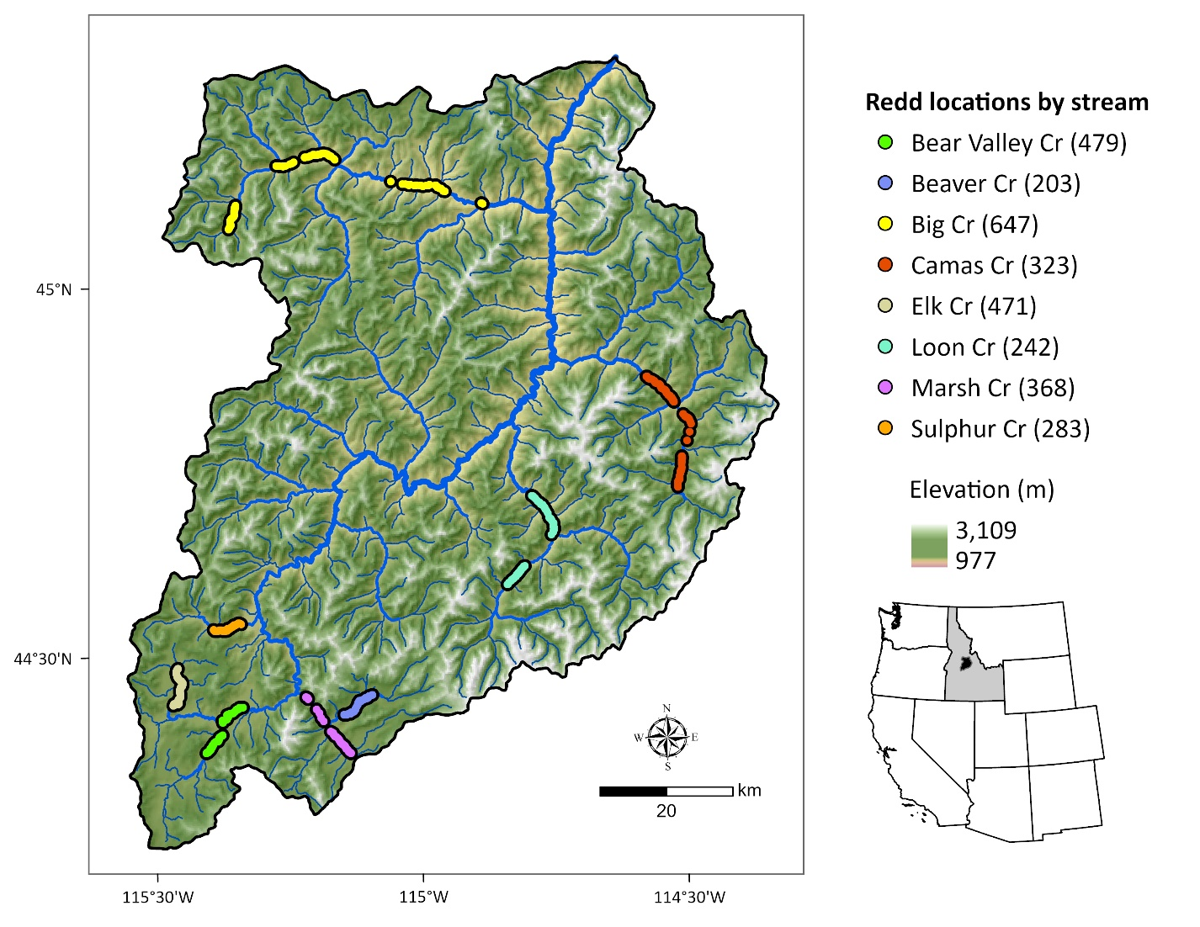Figure 1. Middle Fork Salmon River watershed illustrating major tributaries and locations of georeferenced Chinook Salmon redds from 2002 to 2005 (count of redds per stream given in parentheses). Point locations were dissolved for visualization.

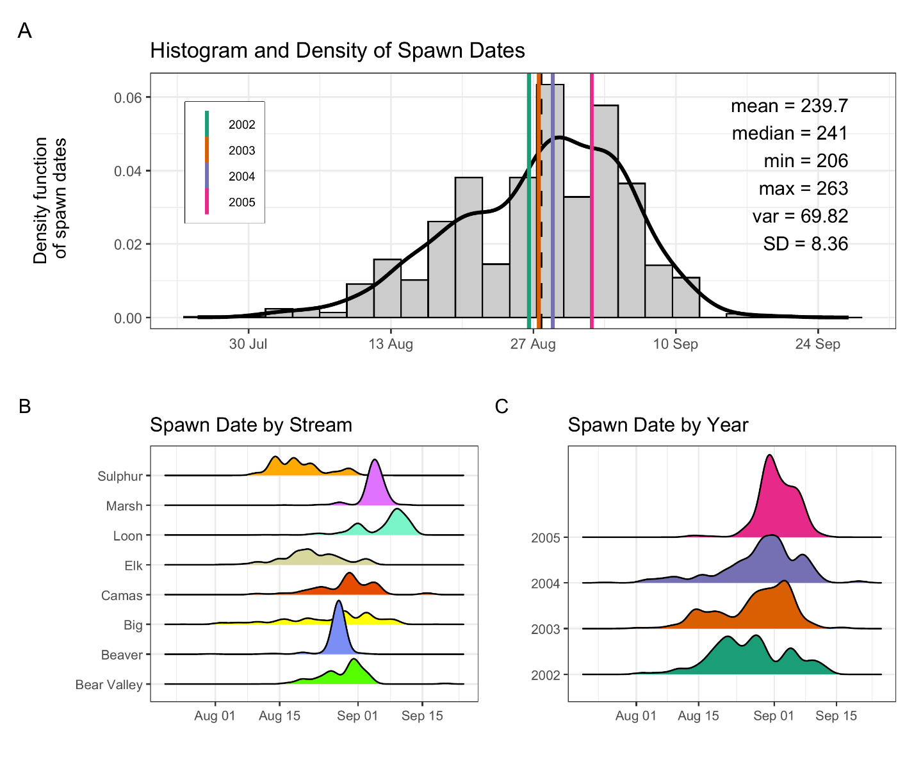
Figure 2: Histogram and density of Chinook salmon spawn timing across all streams and years (A), by stream (B), and by year (C). In panel (A), the histogram and kernel density illustrate the overall distribution of spawn dates; vertical-colored lines illustrate year-specific means, and the black line depicts the global mean. Spawn timing was generally unimodal, peaking in late August to early September.

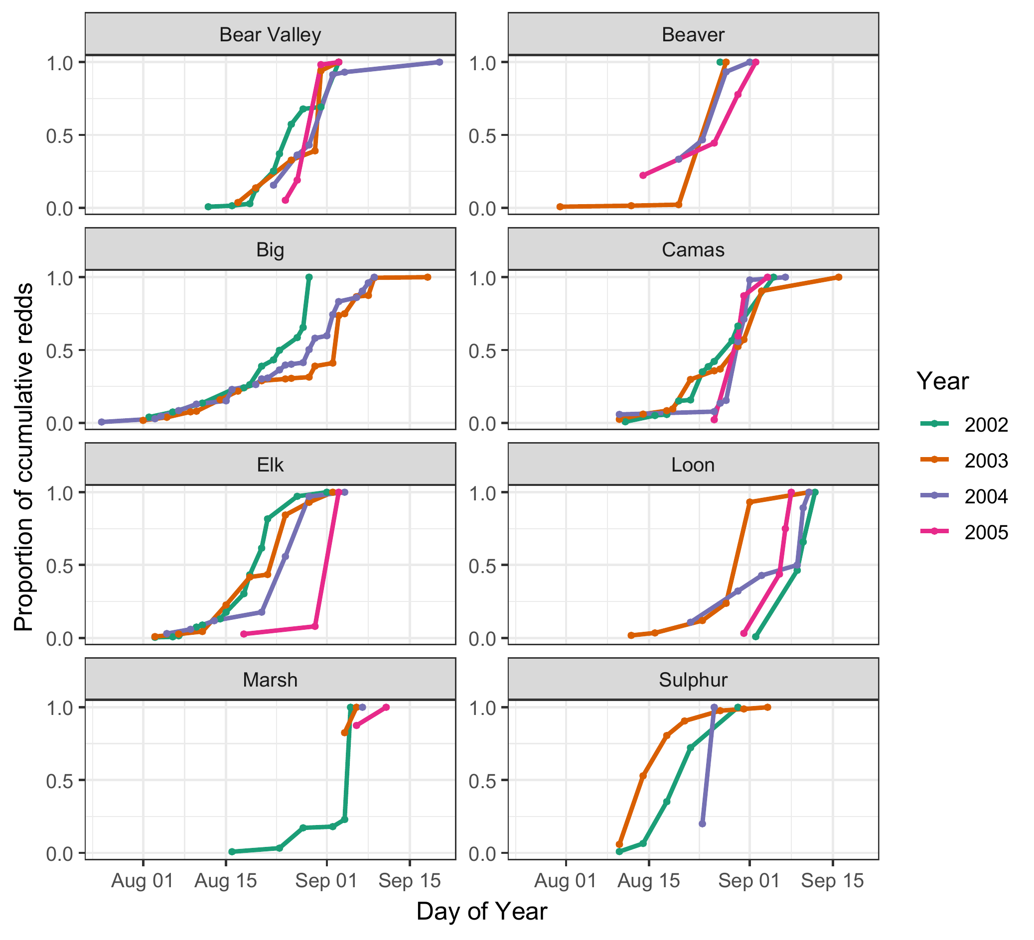
Figure 3. Proportion of cumulative Chinook salmon redds over time (day of year) across years (2002–2005) and streams. Each line represents a different year, denoted by color. Stream-specific panels illustrate temporal variation in the progression of spawning activity, as measured by cumulative redd counts normalized to the maximum value in each stream-year combination. From 2003-2005, only 2, 1, and 2 redd surveys, respectively, were completed in Marsh Creek.

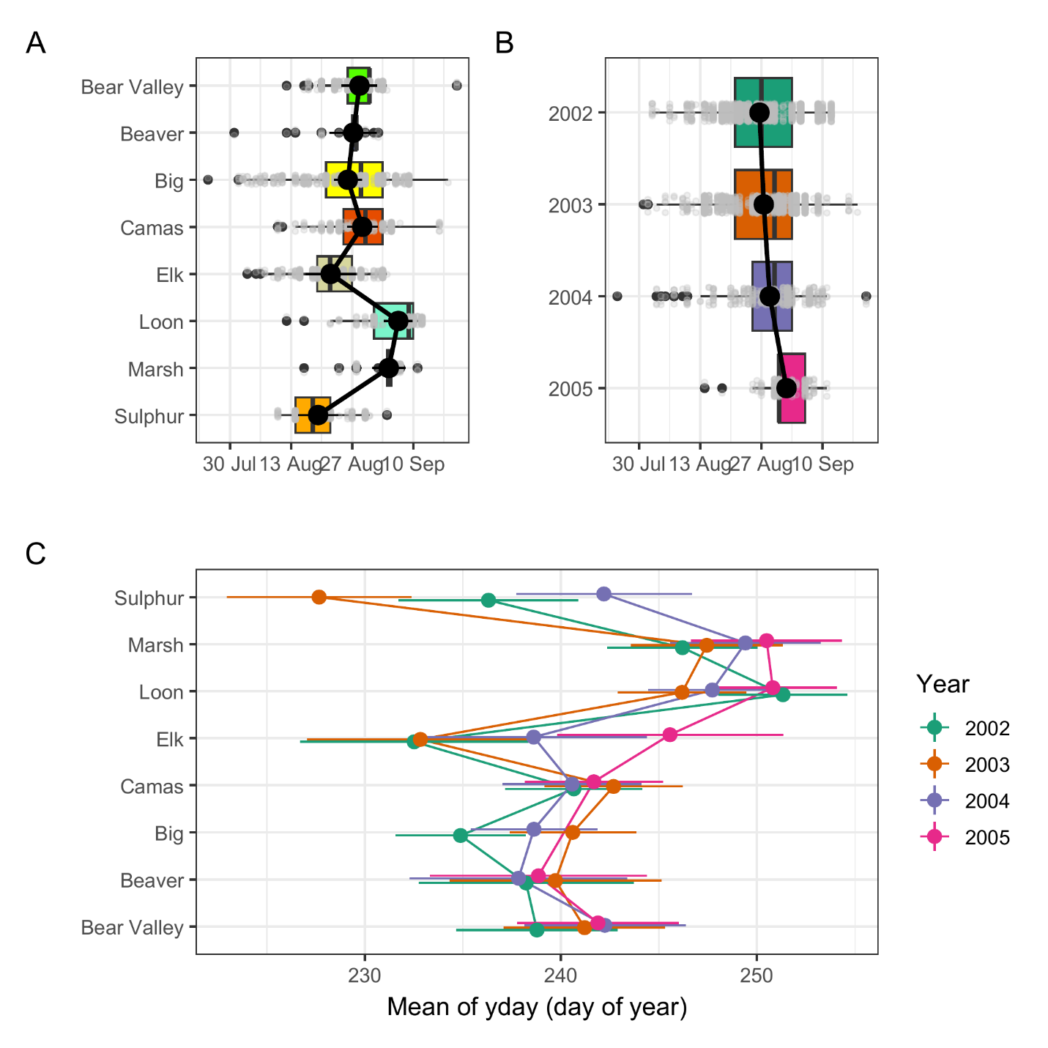
Figure 4. Predicted mean spawn dates by stream (A), year (B) and stream and year (C), from the final mixed-effects model. Black points with black lines (A, B), and colored points with horizontal lines (C) represent estimated marginal means and 95% confidence intervals. Boxplots in panels A and B illustrate the distribution of observed redd counts by group, with individual data points in grey. The modeled predictions represent marginal means accounting for fixed effects and averaged over random effects.
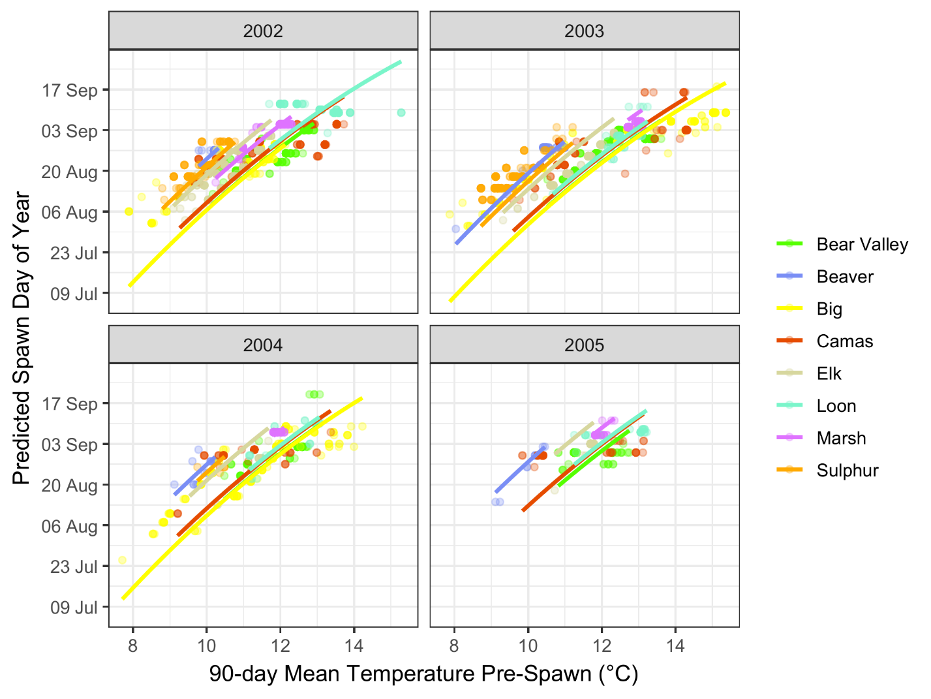
Figure 5. Predicted relationship between spawn timing and 90-day pre-spawn mean temperature by stream and year. Lines represent model predictions from the final mixed-effects model. Colored points illustrate observed spawn timing, shaded ribbons represent 95% confidence intervals for predictions.

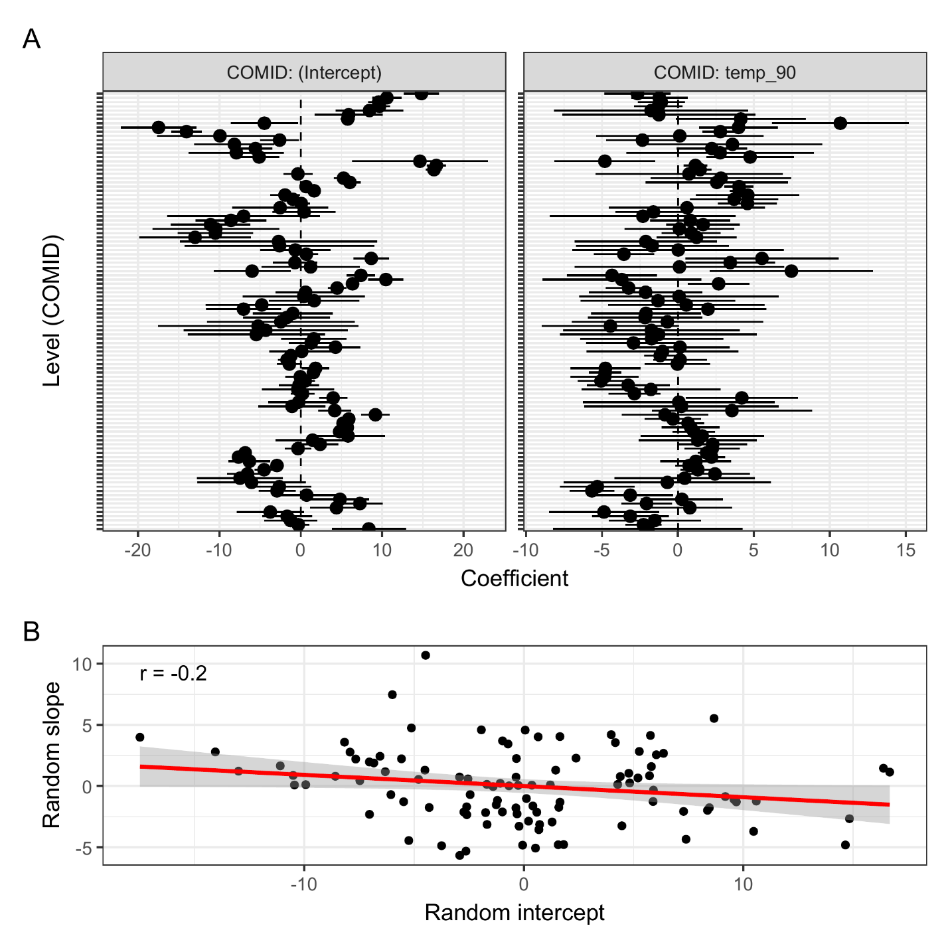
Figure 6: (A) COMID-specific random parameter estimates for intercepts (left) and slopes (right). Points represent best linear unbiased predictions from the final model, with horizontal bars indicating ±1.96 standard errors. (B) Correlation between random intercepts and slopes for 90-day temperature across COMIDs. Each point represents a stream reach (COMID).
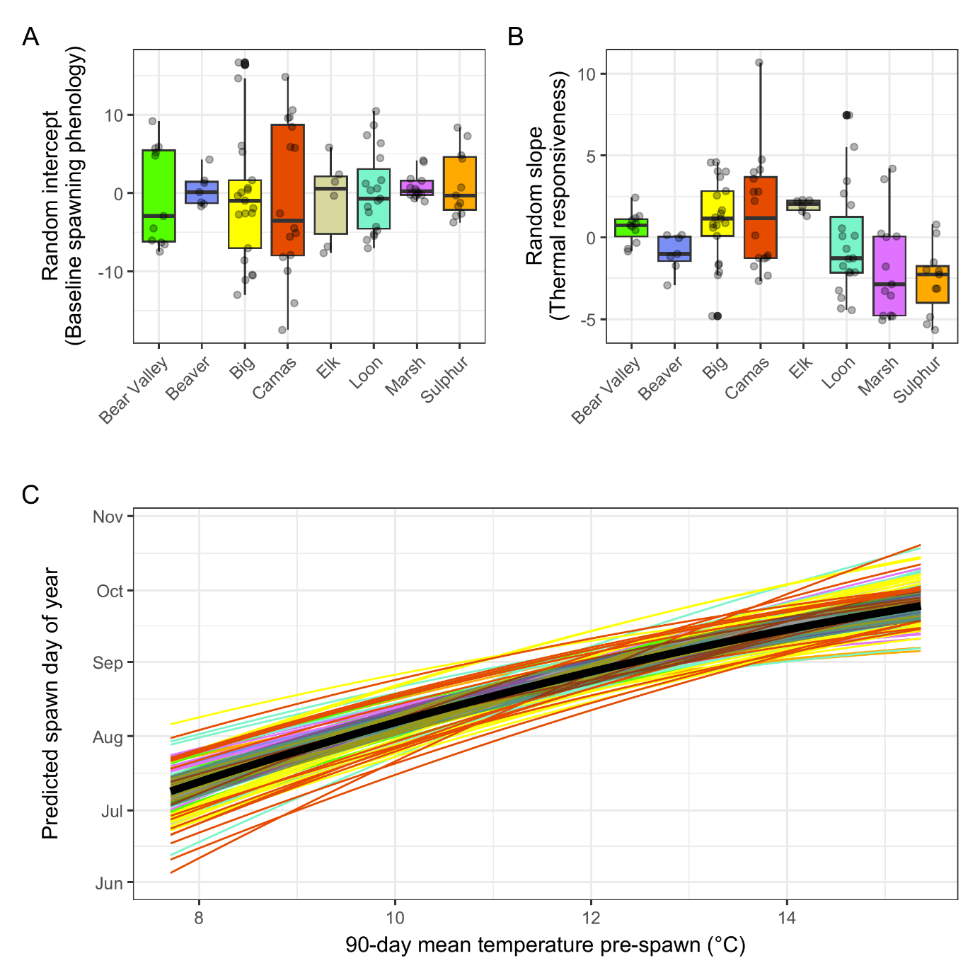

Figure 7. Variation in COMID- and stream-level thermal sensitivity and predicted spawn timing relationships. Boxplots of random intercepts (A) and slopes (C) for 90-day pre-spawn temperature by stream. Each box represents the distribution of best linear unbiased predictions for COMID-level intercepts or slopes. (C) Predicted spawn timing by 90-day pre-spawn temperature and COMID. Each line represents the predicted relationship for a specific COMID (n = 108), colored by stream identity (see panel A and B). The black line and shaded ribbon denote the population-level mean and 95% confidence interval.

